**Linux System Administration Project Documentation**

**Project Title:** **Linux System Administration - Essential Tasks**

**Author:** **Divya M**

**Project Overview:**

**This project demonstrates proficiency in Linux system administration by setting up and managing a Linux environment with essential configurations. It includes disk management, Logical Volume Management (LVM), user management, networking configurations, and file permissions**

**Objectives:**

**Implement disk mounting and LVM for efficient storage management.**

**Manage users and permissions to ensure security.**

**Configure network settings for seamless connectivity.**

**Use key Linux commands for troubleshooting and performance monitoring.**

**1. Introduction**

**Linux system administration is a crucial skill for managing servers and IT infrastructure. This project demonstrates essential Linux administration tasks, including disk mounting, LVM, file permissions, disk management, networking commands, and user management. It provides hands-on experience with real-world scenarios**.

**2. Disk Mounting and Management**

**Objective:**

**Learn how to mount and manage storage devices in Linux.**

**Disk mounting and management in Linux involve attaching storage devices and partitions to specific locations in the system, allowing users to access, manipulate, and organize their data effectively.**

**Disk Mounting and Management Commands in Linux**

**1. Checking Disk Information**

* **lsblk – Lists all block devices and their mount points.**
* **blkid – Displays filesystem type and UUID of partitions.**
* **df -h – Shows available and used disk space in a human-readable format.**
* **mount | column -t – Lists currently mounted filesystems.**

**2. Mounting a Disk**

* **mount /dev/sdX1 /mnt – Mounts partition /dev/sdX1 to the /mnt directory.**
* **mount -t ext4 /dev/sdX1 /mnt – Specifies the filesystem type when mounting.**
* **mount -o rw,relatime /dev/sdX1 /mnt – Mounts with specific options (read/write, etc.).**
* **umount /mnt – Unmounts the partition from /mnt.**

**3. Persistent Mounting (Editing /etc/fstab)**

* **nano /etc/fstab – Opens the file where persistent mounts are configured.**
* **Example entry for persistent mounting:**

**UUID=xxxx-yyyy /mnt ext4 defaults 0 2**

* **mount -a – Applies all mounts listed in /etc/fstab.**

**Tasks:**

* **Identify available disks: lsblk, fdisk -l**
* **Lsblk**

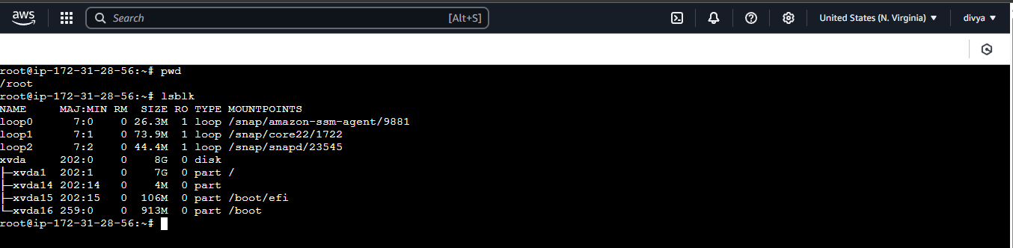

* **If you don’t have disk you can add one disk. go to aws console then create one volume and attached to particular instance.**
* **Lsblk**

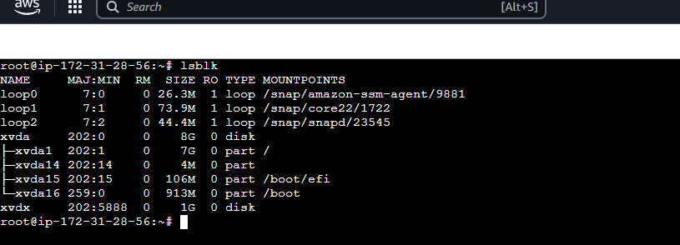

* **Fdisk -l**

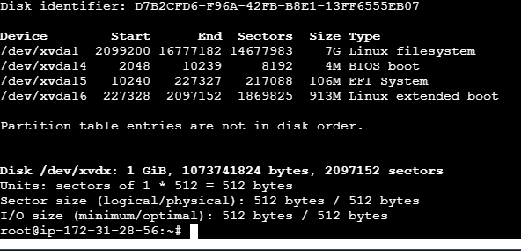

* **Create a new partition**: **fdisk /dev/xvdx**

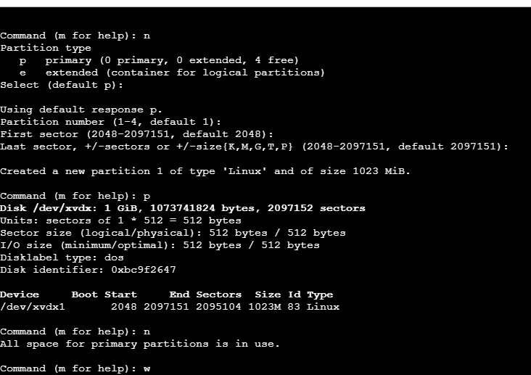

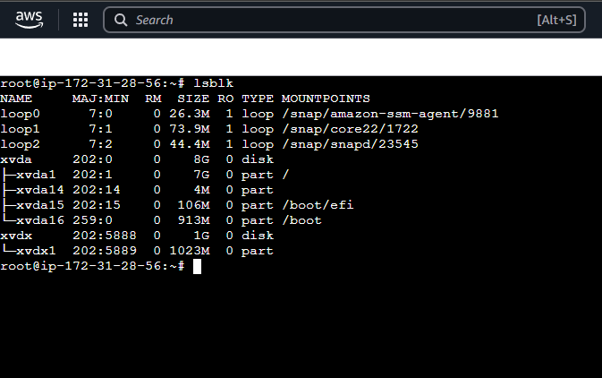

* **Format the partition:**
* **mkfs.ext4 /dev/xvdx1**

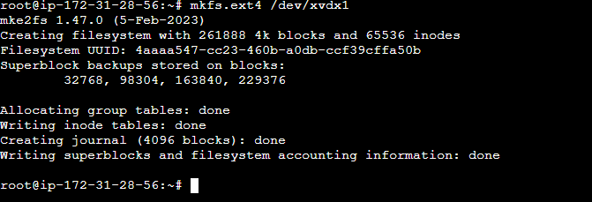

* **create a one directory**
* **mkdir /mnt**
* **Mount the partition:**

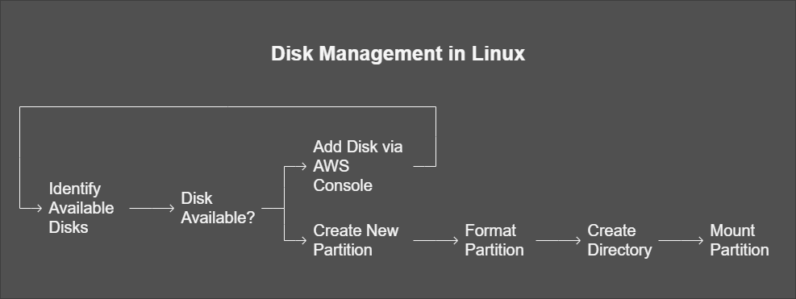

**mount /dev/sdX1 /mnt**

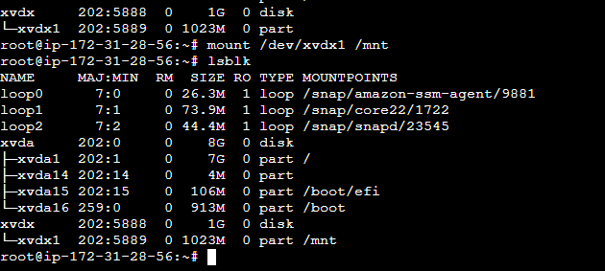

* **Automount using /etc/fstab**
* **We need to the mount persistant use the /etc/fstab**
* **Vi /etc/fstab**
* **/dev/xvdx1 /mnt ext4 defaults 0 0**
* **Save the file**

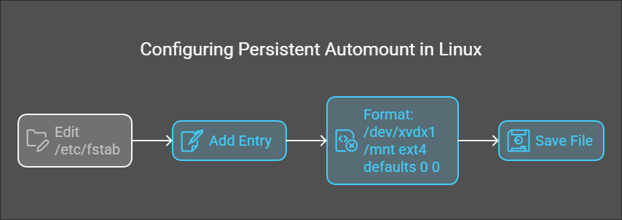

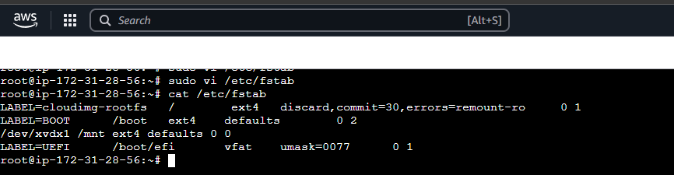

**3. Logical Volume Management (LVM)**

**Objective:**

**Understand LVM concepts and create flexible storage solutions.**

**Logical Volume Management (LVM) in Linux is a flexible disk management system that allows users to dynamically allocate, resize, and manage storage more efficiently than traditional partitioning methods. LVM provides advanced features like snapshots, resizing, and easy disk management across multiple physical volumes.**

**Key Concepts in LVM**

1. **Physical Volume (PV) – A physical storage device (e.g., hard drive or partition) initialized for LVM.**
2. **Volume Group (VG) – A collection of physical volumes combined into a single storage pool.**
3. **Logical Volume (LV) – A flexible partition created within a volume group, used like a traditional partition.**
4. **File System – The format applied to a logical volume to store and manage files.**

**Essential LVM Commands**

**1. Initializing Physical Volumes**

* **pvcreate /dev/sdX – Initializes a physical volume for use with LVM.**
* **pvdisplay – Displays information about physical volumes.**
* **pvs – Lists all physical volumes in a concise format.**

**2. Creating and Managing Volume Groups**

* **vgcreate my_vg /dev/sdX /dev/sdY – Creates a volume group named my_vg using multiple physical volumes.**
* **vgextend my_vg /dev/sdZ – Adds another physical volume to an existing volume group.**
* **vgreduce my_vg /dev/sdX – Removes a physical volume from a volume group.**
* **vgdisplay – Shows detailed information about volume groups.**
* **vgs – Lists all volume groups briefly.**

**3. Creating and Managing Logical Volumes**

* **lvcreate -L 10G -n my_lv my_vg – Creates a logical volume my_lv of 10GB in my_vg.**
* **lvextend -L +5G /dev/my_vg/my_lv – Expands my_lv by 5GB.**
* **lvreduce -L -5G /dev/my_vg/my_lv – Shrinks my_lv by 5GB.**
* **lvremove /dev/my_vg/my_lv – Deletes a logical volume.**
* **lvdisplay – Shows detailed information about logical volumes.**
* **lvs – Lists logical volumes in a short format.**

**4. Formatting and Mounting Logical Volumes**

* **mkfs.ext4 /dev/my_vg/my_lv – Formats the logical volume with the ext4 filesystem.**
* **mount /dev/my_vg/my_lv /mnt – Mounts the logical volume to /mnt.**
* **umount /mnt – Unmounts the volume.**

**5. Taking Snapshots**

* **lvcreate -L 5G -s -n my_lv_snapshot /dev/my_vg/my_lv – Creates a snapshot of a logical volume.**
* **lvremove /dev/my_vg/my_lv_snapshot – Deletes the snapshot.**

**6. Checking LVM Status**

* **lsblk – Displays all storage devices including LVM partitions.**
* **df -h – Shows available disk space.**
* **vgscan – Scans the system for available volume groups.**

**Tasks:**

* **Create Physical Volume (PV): pvcreate /dev/sdX**

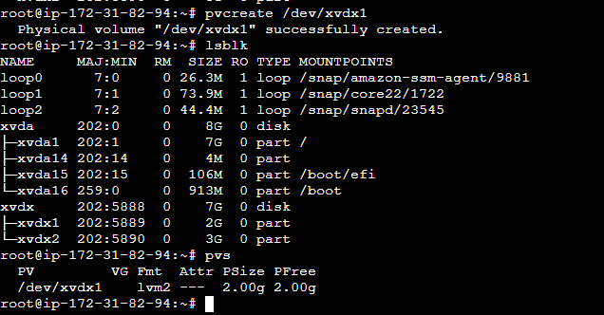

* **Create Volume Group (VG):**
* **vgcreate divya_vg /dev/xvdx1**

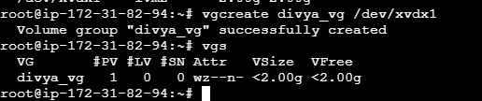

* **Create Logical Volume (LV):**
* **lvcreate -L 1G -n divya_lv divya_vg**

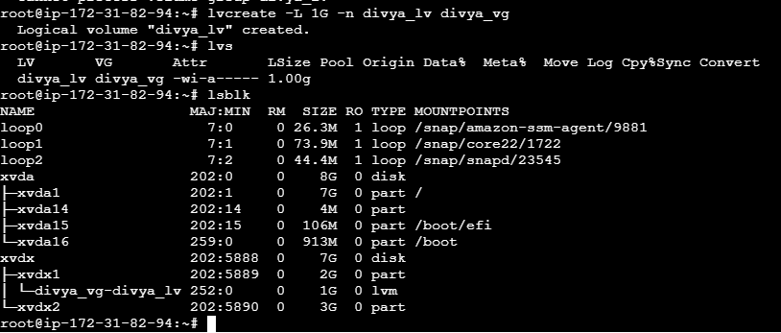

* **Format and mount the LV:**
* **mkfs.ext4 /dev/divya_vg/divya_lv**
* **mount:**
* **sudo mount /dev/divya_vg/divya_lv /mnt**

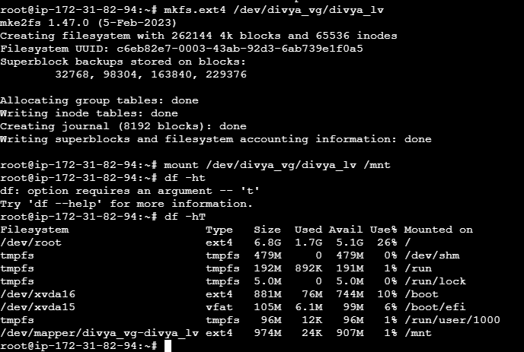

* **if we need extend the logical volume so we need to first umount**
* **command:**
* **umount /mnt**

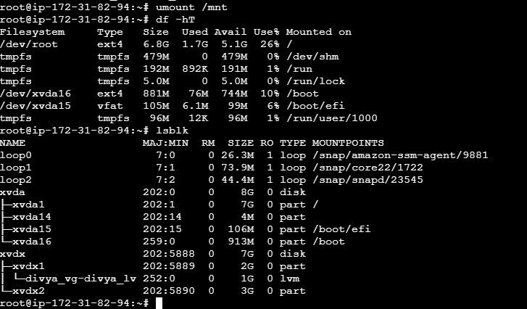

* **Extend an LV:**
* **lvextend -L +2G /dev/divya_vg/divya_lv**
* **mount command;**
* **mount /dev/divya_vg/divya_lv /mnt**

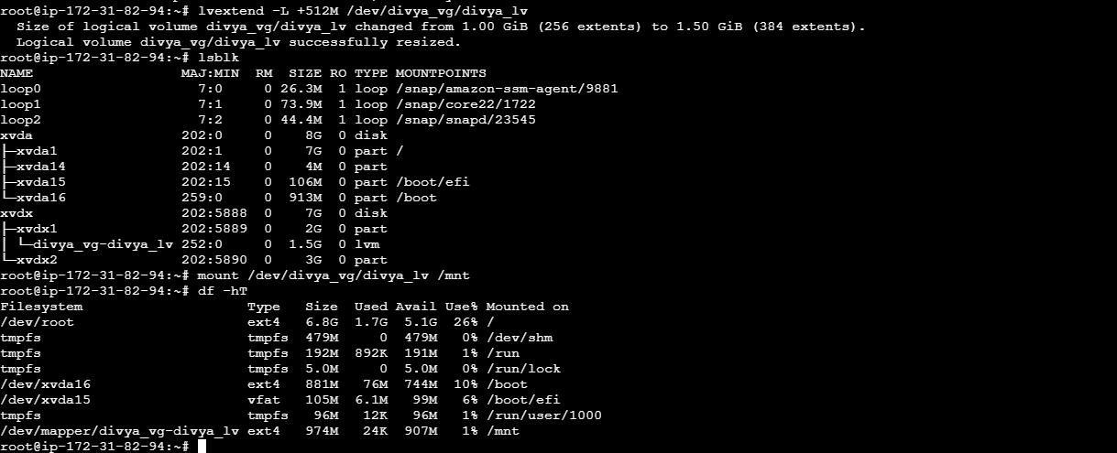

* **if we need logical volume management persistence using add entre in /etc/fstab**
* **command: vi /etc/fstab**
* **/dev/divya_vg/divya_lv /mnt ext4 default 0 0**
* **Even system will reboot the mount point also there**

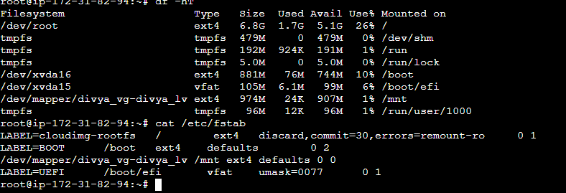

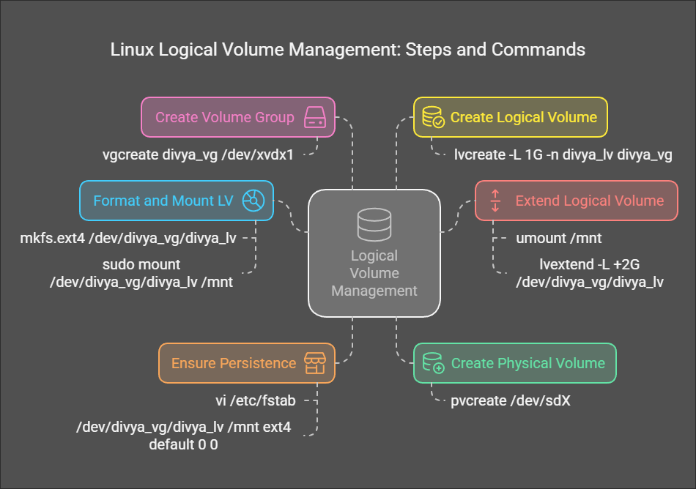

**4. File Permissions and Management**

**Objective:**

* **File permission and management in Linux ensure that users and processes have appropriate access to files while maintaining security. Linux assigns permissions based on users, groups, and access modes—read, write, and execute.**
* **Understanding File Permissions in Linux**
* **Each file has three types of access permissions:**
* **User (Owner): Permissions for the file's owner.**
* **Group: Permissions for the group associated with the file.**
* **Others: Permissions for all other users.**
* **Each file also has three types of access rights:**
* **Read (r): Allows viewing the file's content.**
* **Write (w): Allows modifying the file's content.**
* **Execute (x): Allows running the file as a program/script.**
* **Permissions are displayed using ls -l, like this:**
* **-rw-r--r-- 1 user group 1234 May 21 file.txt**
* **Where:**
* **rw- (Owner) = Read, Write.**
* **r-- (Group) = Read-only.**
* **r-- (Others) = Read-only.**
* **File Permission Commands**
* **1. Checking File Permissions**
* **ls -l – Displays permissions of a file.**
* **stat – Provides detailed file information, including permissions.**
* **2. Changing File Permissions**
* **chmod 755 – Sets specific permissions using numeric mode (7=RWX, 5=RX).**
* **chmod u+x – Grants execute permission to the file owner (u=user).**
* **chmod g-w – Removes write permission from the group (g=group).**
* **chmod o+r – Gives read permission to others (o=others).**
* **3. Changing Ownership**
* **chown user – Changes the owner of a file.**
* **chown user:group – Changes both user and group ownership.**
* **chgrp group – Changes the group ownership of a file.**
* **4. Managing Special Permissions**
* **chmod +s – Sets the SetUID bit, allowing execution with owner's privileges.**
* **chmod +g – Sets the SetGID bit, making a file inherit the group of the directory.**
* **chmod +t – Sets the Sticky Bit, allowing only the owner to delete files.**
* **File Management Commands**
* **5. Creating and Removing Files**
* **touch – Creates an empty file.**
* **mkdir – Creates a new directory.**
* **rm – Deletes a file.**
* **rmdir – Deletes an empty directory.**
* **rm -r – Deletes a directory with its contents.**
* **6. Copying and Moving Files**
* **cp – Copies files.**
* **mv – Moves or renames files.**
* **cp -r – Copies directories recursively.**
* **7. Viewing and Editing Files**
* **cat – Displays the file content.**
* **nano – Opens the file in a simple text editor.**
* **vim – Opens the file in a powerful text editor.**
* **Understand file permissions and security in Linux.**
* **In linux file permissions like read,write,execute.**
* **There are three positions [known as permission gets]to represent permissions for each category**
* **Rwx|rwx|rwx**

**| u | g | o |**

**U=user, g=group, o=others**

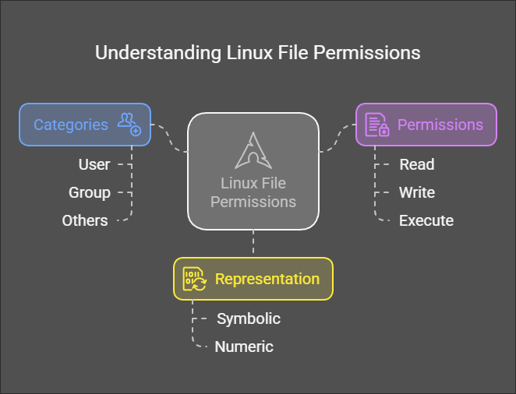

* **Change file permission in two ways one is numeric mode another one is symbolic mode.**
* **Symbolic mode numeric mode**
* **R=read +**
* **W=write -**
* **X=execute =**
* **-=no permission 1,2,3,4,5,6,7**
* **111-only execution,222-only write,333-write and execution,444-only read 555-read and execution 666-read and write 777-read and write, execution.**
* **File permission change use command: chmod [-R] permission file/dir.**

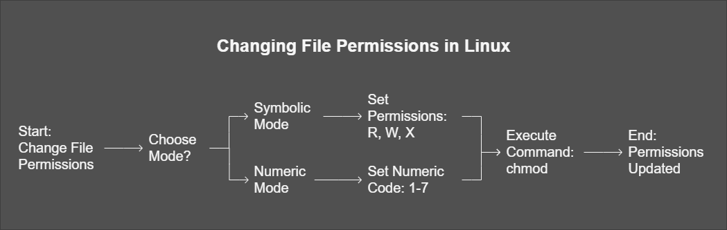

**Tasks:**

* **View file permissions: ls -l**
* **Modify permissions using chmod command: chmod permission file/directory**
* **Example: chmod 755 divya**
* **Chmod -R 644 hello**

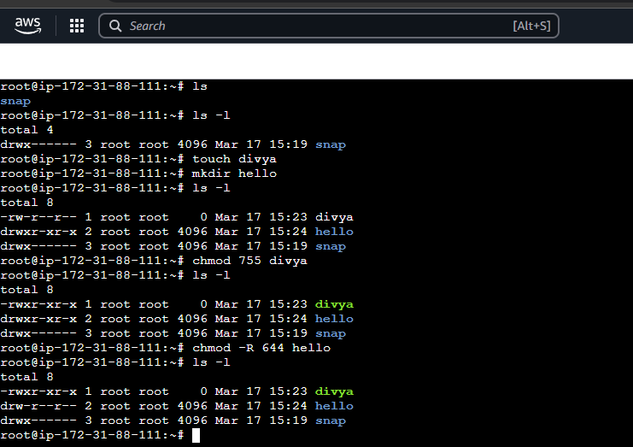

**Permission Breakdown**

* **Read (4), Write (2), Execute (1):** 
  + **755 = Owner (rwx), Group (rx), Others (rx).**
  + **644 = Owner (rw), Group (r), Others (r).**
* **Change ownership: chown user:group filename**
* **Example: chown padhu:sun kernel.txt**
* **Here padhu is user, sun is group filename is kernel.txt**

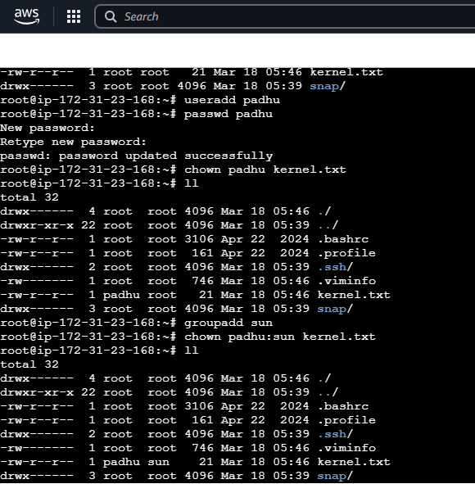

* **Some special file permission there in linux i.e, suid, sgid, stickybit .**

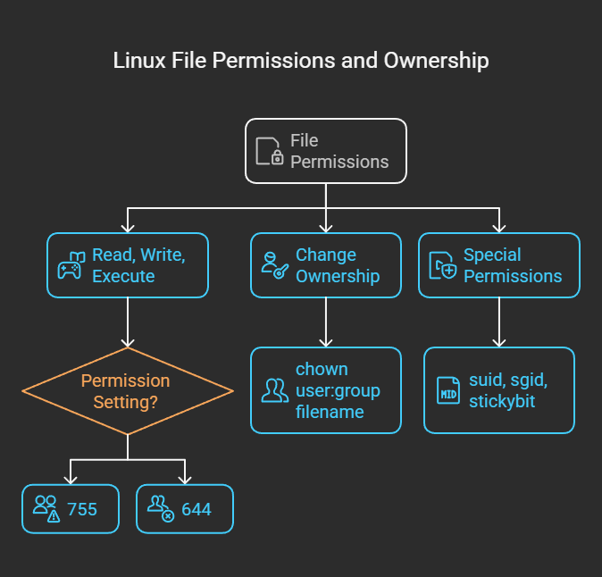

**• Set special permissions:**

* **SUID: chmod u+s filename**
* **SGID: chmod g+s directory_name**
* **Sticky Bit: chmod +t directory_name**
* **SUID(set user id ): allows to exceue a program with the privilages of the file’s owner,not their own.**
* **SGID(set group id): enables a user to execute a program with the privilages of the file’s group not their own**
* **STICKY BIT: when set on directory, it restricts deletion or renaming of files and subdirectories within that directory to only the owner,the directory owner,or root.**
* **Example SUID: chmod u+s heelo.txt**

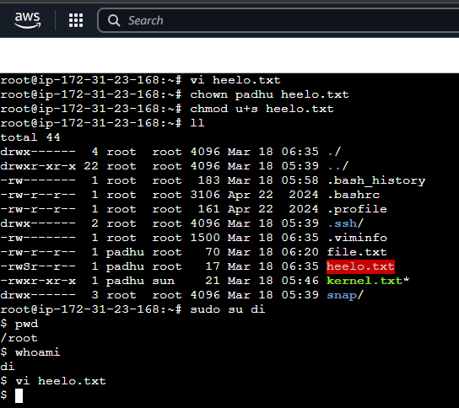

* **Example SGID: chmod g+s dir.txt**

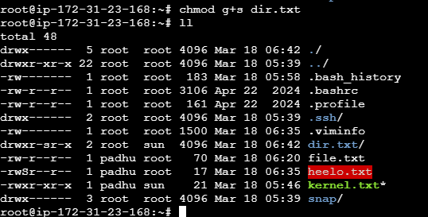

* **Example STICKY BIT: chmod +t directory.txt**

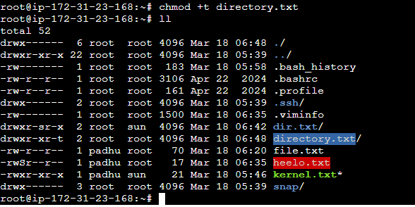

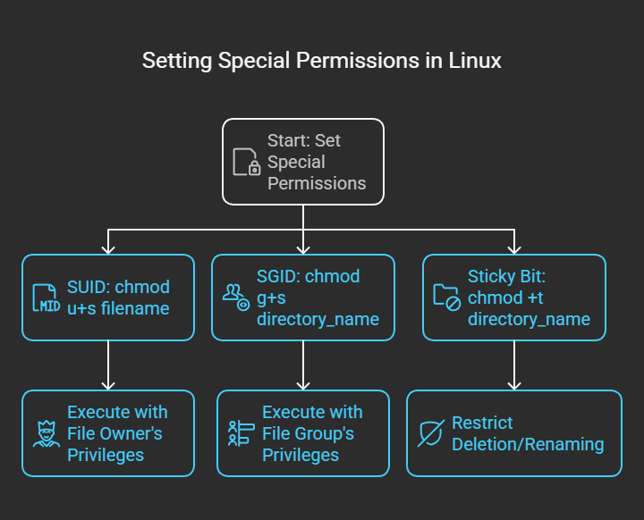

**5. Disk Management**

**Objective:**

**Monitor and manage disk usage.**

**Disk management in Linux involves handling storage devices, partitions, and file systems to ensure efficient data organization and system performance. Administrators use various commands to inspect, modify, format, and mount disks.**

**Essential Linux Disk Management Commands:**

**1. Checking Disk Information**

* **lsblk – Lists all block devices, showing disk partitions.**
* **fdisk -l – Displays partition details of all connected storage devices.**
* **blkid – Shows UUID and filesystem type of partitions.**
* **df -h – Displays disk space usage in a human-readable format.**
* **du -sh – Displays the size of a specific directory.**

**2. Managing Partitions**

* **fdisk /dev/sdX – Opens the partition tool for disk /dev/sdX.**
* **parted /dev/sdX – Another partitioning tool that supports GPT.**
* **mkfs.ext4 /dev/sdX1 – Formats partition /dev/sdX1 with the ext4 filesystem.**
* **tune2fs -m 5 /dev/sdX1 – Adjusts reserved space percentage on an ext4 partition.**

**3. Mounting and Unmounting Disks**

* **mount /dev/sdX1 /mnt – Mounts partition /dev/sdX1 to /mnt.**
* **umount /mnt – Unmounts the partition from /mnt.**
* **mount -o rw,remount /dev/sdX1 – Remounts a filesystem with read/write access.**

**4. Managing Logical Volumes (LVM)**

* **pvcreate /dev/sdX1 – Initializes a partition for use with LVM.**
* **vgcreate my_vg /dev/sdX1 – Creates a volume group named my_vg.**
* **lvcreate -L 10G -n my_lv my_vg – Creates a logical volume my_lv of 10GB.**
* **lvextend -L +5G /dev/my_vg/my_lv – Increases the size of a logical volume by 5GB.**
* **resize2fs /dev/my_vg/my_lv – Resizes the filesystem after extending the volume.**

**5. Checking and Repairing Filesystems**

* **fsck /dev/sdX1 – Checks and repairs filesystem errors.**
* **e2fsck -p /dev/sdX1 – Runs automatic repair on an ext4 filesystem.**
* **badblocks -v /dev/sdX1 – Scans for bad sectors on a disk.**

**6. Viewing Disk I/O Performance**

* **iostat – Displays CPU and disk I/O statistics.**
* **iotop – Shows real-time disk usage per process.**
* **hdparm -tT /dev/sdX – Measures disk read performance.**

**Tasks:**

**Steps**

* **Monitor usage with df and du.**
* **Partition and format new disks as needed.**
* **Check health with smartctl.**
* **Check disk usage: df -h**

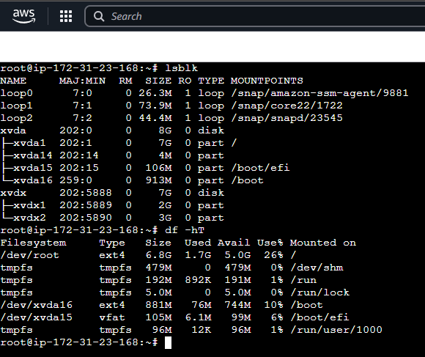

* **Check inode usage: df -i**

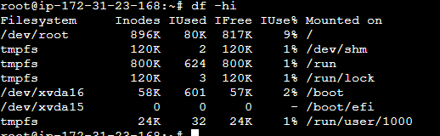

* **Display disk space usage by directory: du -sh /path**

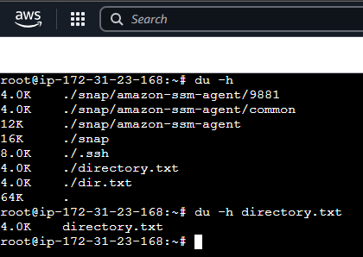

* **Format a partition:**
* **Sudo mkfs.ext4 /dev/xvdx2**

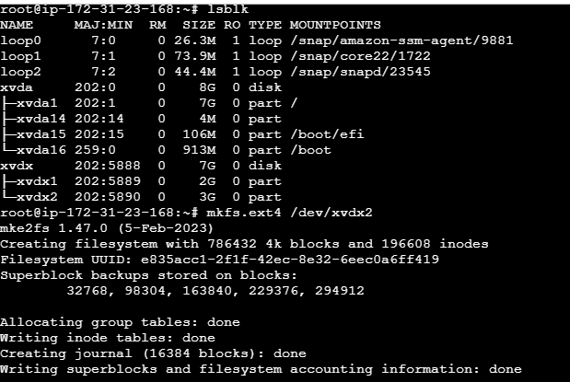

* **Check disk health:**
* **sudo smartctl -a /dev/xvdx2**
* **if incase smartcl is command not found you need to install**
* **apt install smartmontools # Or use yum/dnf based on your distro**
* **smartctl -a /dev/xvdx2**

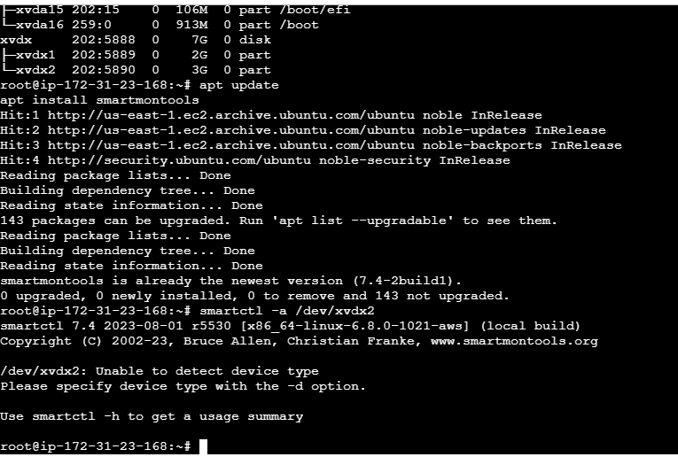

* **Monitor disk I/O: iostat, iotop**
* **Steps to Install**
* **Update the package list (optional but recommended to ensure you get the latest versions**
* **apt update**
* **Install sysstat for iostat command:**
* **apt install sysstat**
* **Install iotop command:**
* **apt install iotop**
* **Running the Commands**
* **After installation, you can use iostat to check disk I/O statistics. For example**
* **iostat -x 1**
* **For iotop, run it with sudo to monitor real-time I/O usage by processes**
* **sudo iotop**

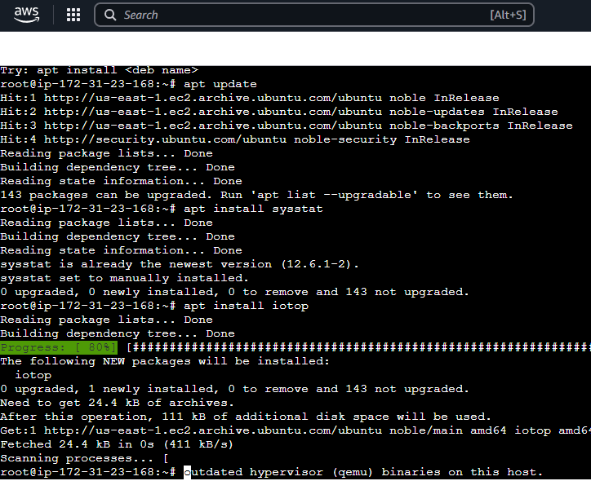

* **command: iostat**

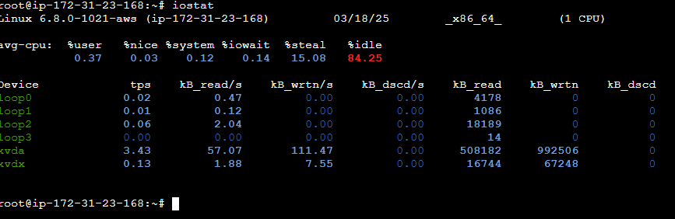

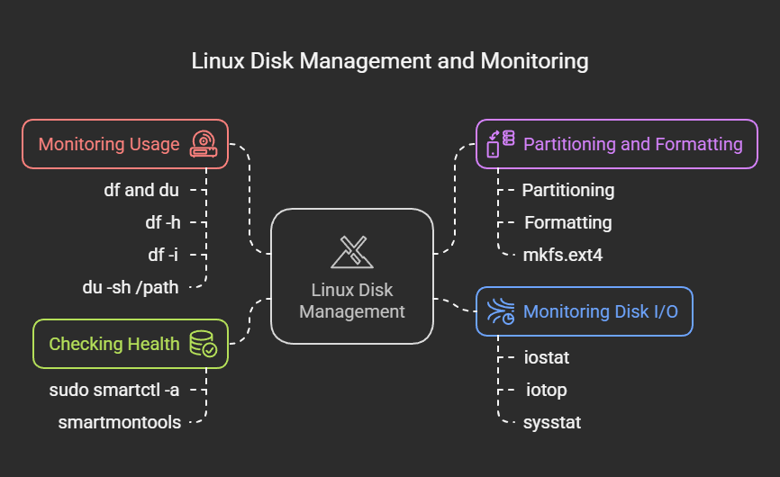

**6. Networking Commands**

**Objective:**

**Understand basic networking commands.**

**Networking in Linux refers to the configuration and management of network connections, interfaces, and protocols to enable communication between systems. Linux provides powerful tools and commands for monitoring, troubleshooting, and managing networks.**

**Essential Linux Network Commands:**

**1. Checking Network Configuration**

* **ifconfig – Displays network interfaces and IP addresses (deprecated, replaced by ip command).**
* **ip addr show – Shows IP addresses assigned to interfaces.**
* **ip link show – Displays network interface details.**
* **nmcli device status – Checks the status of network devices.**

**2. Managing Network Interfaces**

* **ifconfig eth0 down – Disables a network interface.**
* **ifconfig eth0 up – Enables a network interface.**
* **ip link set eth0 down – Another way to disable an interface.**
* **ip link set eth0 up – Enables an interface using the ip command.**
* **iwconfig – Configures wireless interfaces.**

**3. Checking Network Connections**

* **ping – Tests network connectivity.**
* **traceroute – Shows the path packets take to a destination.**
* **netstat -tunlp – Displays active network connections and listening ports.**
* **ss -tunlp – An improved alternative to netstat.**
* **curl -I – Fetches HTTP headers of a webpage.**

**4. Managing Network Routing**

* **route -n – Displays the routing table (deprecated, use ip command).**
* **ip route show – Shows the routing table.**
* **ip route add via – Adds a static route.**
* **ip route del – Deletes a static route.**

**5. DNS Lookup & Host Resolution**

* **nslookup – Queries DNS servers (deprecated, use dig).**
* **dig – Performs a detailed DNS lookup.**
* **host – Resolves hostnames to IP addresses.**

**6. Port and Firewall Management**

* **iptables -L – Lists firewall rules.**
* **iptables -A INPUT -p tcp --dport 80 -j ACCEPT – Allows traffic on port 80.**
* **firewall-cmd --list-all – Lists firewall settings (for systems using firewalld).**
* **ufw status – Shows firewall status (for systems using ufw).**

**7. Network Traffic Monitoring**

* **tcpdump -i eth0 – Captures network packets on a specified interface.**
* **iftop – Displays live bandwidth usage per connection.**
* **nmap -sP – Scans for active hosts on a network.**

**Tasks:**

**Commands**

* **Check IP address:**
* **ip addr**

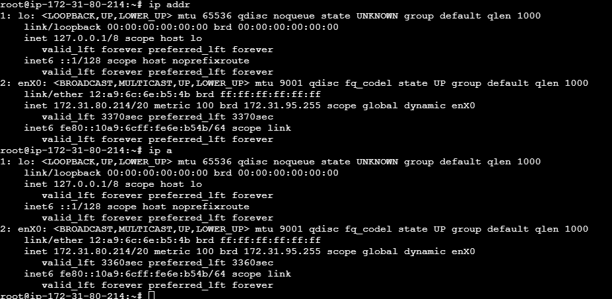

* **Explanation: Shows network interfaces. lo is the loopback interface (127.0.0.1), and eth0 has an IP of 172.31.80.214.**
* **Ping a host:**
* **ping google.com -c 4**

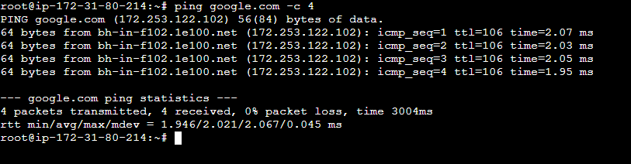

* **Explanation: Tests connectivity to google.com. The -c 4 limits it to 4 pings. Latency is around 15 ms with no packet loss.**
* **View network interfaces:**
* **Ifconfig**
* **Incase this is command not found so you need to install.**

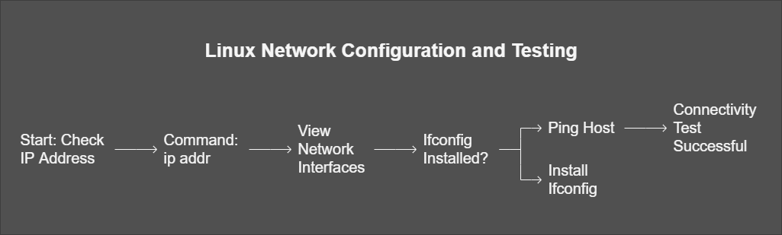

**How to Install ifconfig (net-tools)**

**Since you’re logged in as root (indicated by root@ip-172-31-80-214), you can directly run the installation command without needing sudo.**

**Step-by-Step Instructions**

* **Update the Package List** (optional but recommended):  
  Ensure your package list is up-to-date to avoid issues with outdated repositories.
* **apt update**

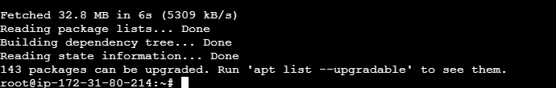

* **Install net-tools:  
  Run the command suggested in the error message:**
* **apt install net-tools**

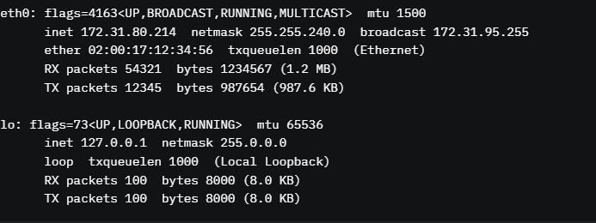

* **ifcong**

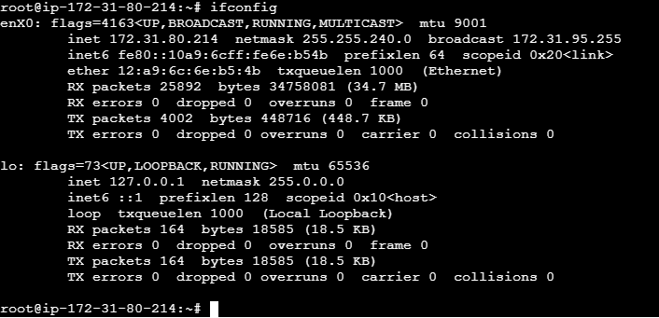

* **Explanation: Displays interface details. eth0 shows the IP, netmask, and traffic stats. Note: ifconfig may require the net-tools package.**
* **Restart networking (Ubuntu):**
* **sudo systemctl restart networking**
* **The error Unit networking.service not found indicates that the networking.service is not available on your system. This is common in newer Linux distributions, especially those using systemd, like Ubuntu 16.04 and later, where traditional networking.service has been replaced by other network management tools such as NetworkManager or systemd-networkd. The exact solution depends on your system's network configuration.**
* **systemctl status systemd-networkd**

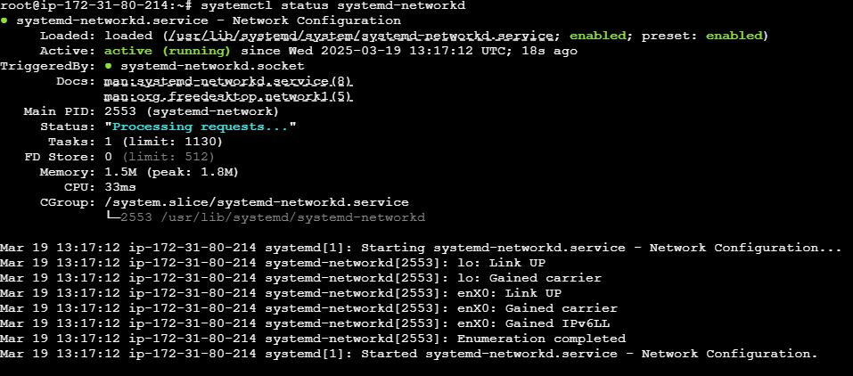

* **Display routing table:**
* **route -n**

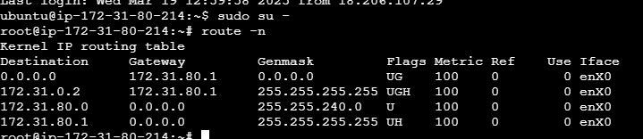

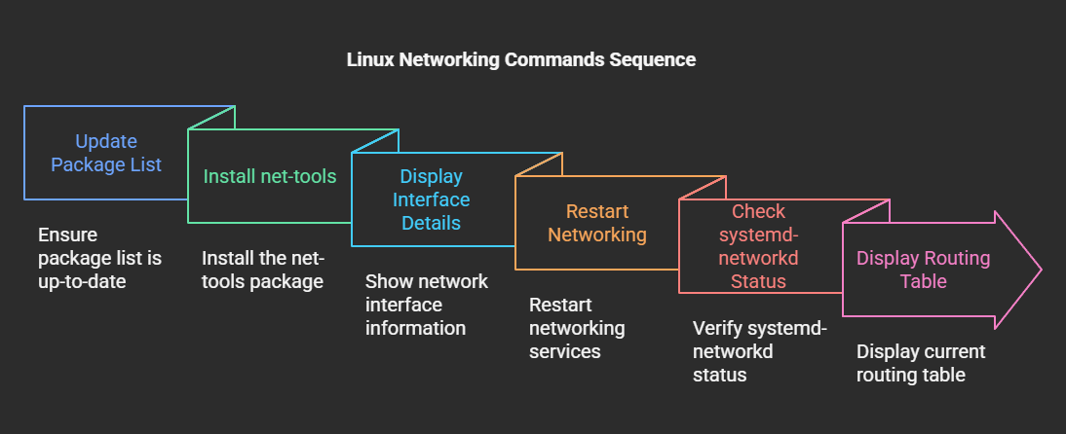

**7. User Management**

**Objective:**

**Manage users and groups in Linux.**

**User management in Linux is all about handling users and their permissions, ensuring that different people or processes can access the system securely. It involves adding, removing, modifying users, and managing their group memberships.**

**Key Commands for User Management:**

1. **Creating a User**
   * **useradd – Creates a new user.**
   * **passwd – Sets or changes the password for a user.**
2. **Modifying a User**
   * **usermod -aG – Adds a user to a group.**
   * **usermod -l – Changes a username.**
   * **usermod -d /new/home/directory – Updates the user's home directory.**
3. **Deleting a User**
   * **userdel – Removes a user account.**
   * **userdel -r – Deletes a user and their home directory.**
4. **Managing Groups**
   * **groupadd – Creates a new group.**
   * **groupdel – Deletes a group.**
   * **groupmod -n – Renames a group.**
5. **Checking User Information**
   * **id – Displays the user ID (UID) and group ID (GID).**
   * **who or w – Shows who is currently logged in.**
   * **cat /etc/passwd – Lists all users in the system.**
6. **Changing User Privileges**

* **sudo – Runs a command as the superuser.**
* **visudo – Edits the sudoers file to manage user privileges.**

**Linux user management helps maintain security and organization, ensuring users only access what they need. Need help with a specific command?**

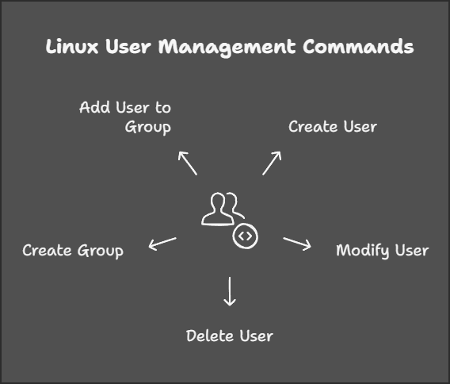

**Tasks:**

**Add a user:**

* **Useradd options username**
* **Options:**
* **-u=uid**
* **-g=primary group id**
* **-G= supplementary groups**
* **-c=gicous(comment)**
* **-d=home directory**
* **-s=shell**
* **Set user password**
* **Particular user we need to set password.so here is command**
* **Passwd username.**
* **For example:**
* **Useradd -u 30001 -c “testuser” -d /home/app -s /bin/bash app**
* **Passwd app**
* Verify with id username.
* **Id app**
* **Modify user details: usermod -c "New User" username**
* **Example:**
* **Usermod -c “hello world” app**
* **Create a group: groupadd groupname**
* **Example :**
* **Groupadd webapp**
* **Add user to a group: usermod -aG groupname username**
* **Example:**
* **Usermod -aG webapp app**
* **Delete a user: userdel -r username**
* **Example:**
* **Userdel -r app**

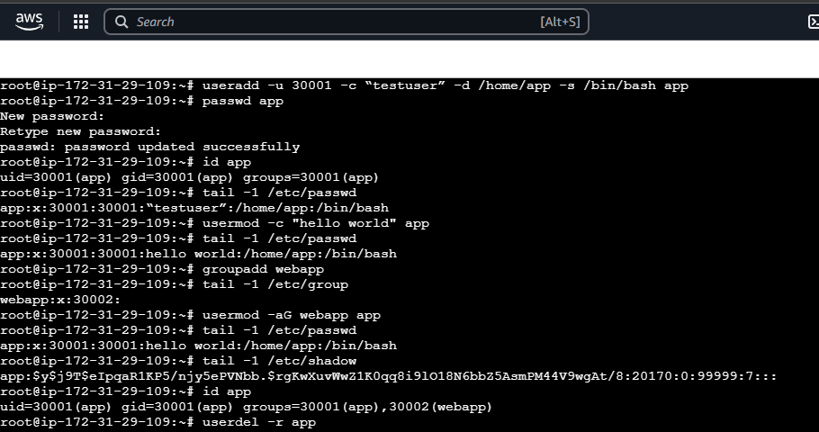

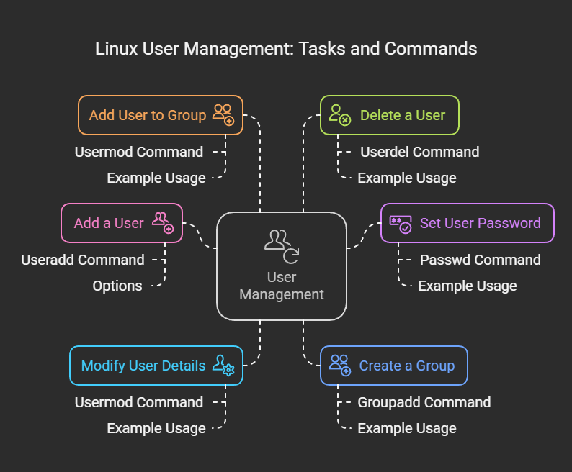

**8. Conclusion**

**Mastering Linux system administration is an invaluable skill for IT professionals. This project covers critical administrative tasks, equipping you with practical experience in managing storage, file permissions, networking, and user accounts. By systematically documenting and reporting these activities, you ensure better troubleshooting, enhanced security, and efficient system performance.**